Puck Yeah Maintenance Plan

Puck Yeah is a web based multiplayer air hockey game.

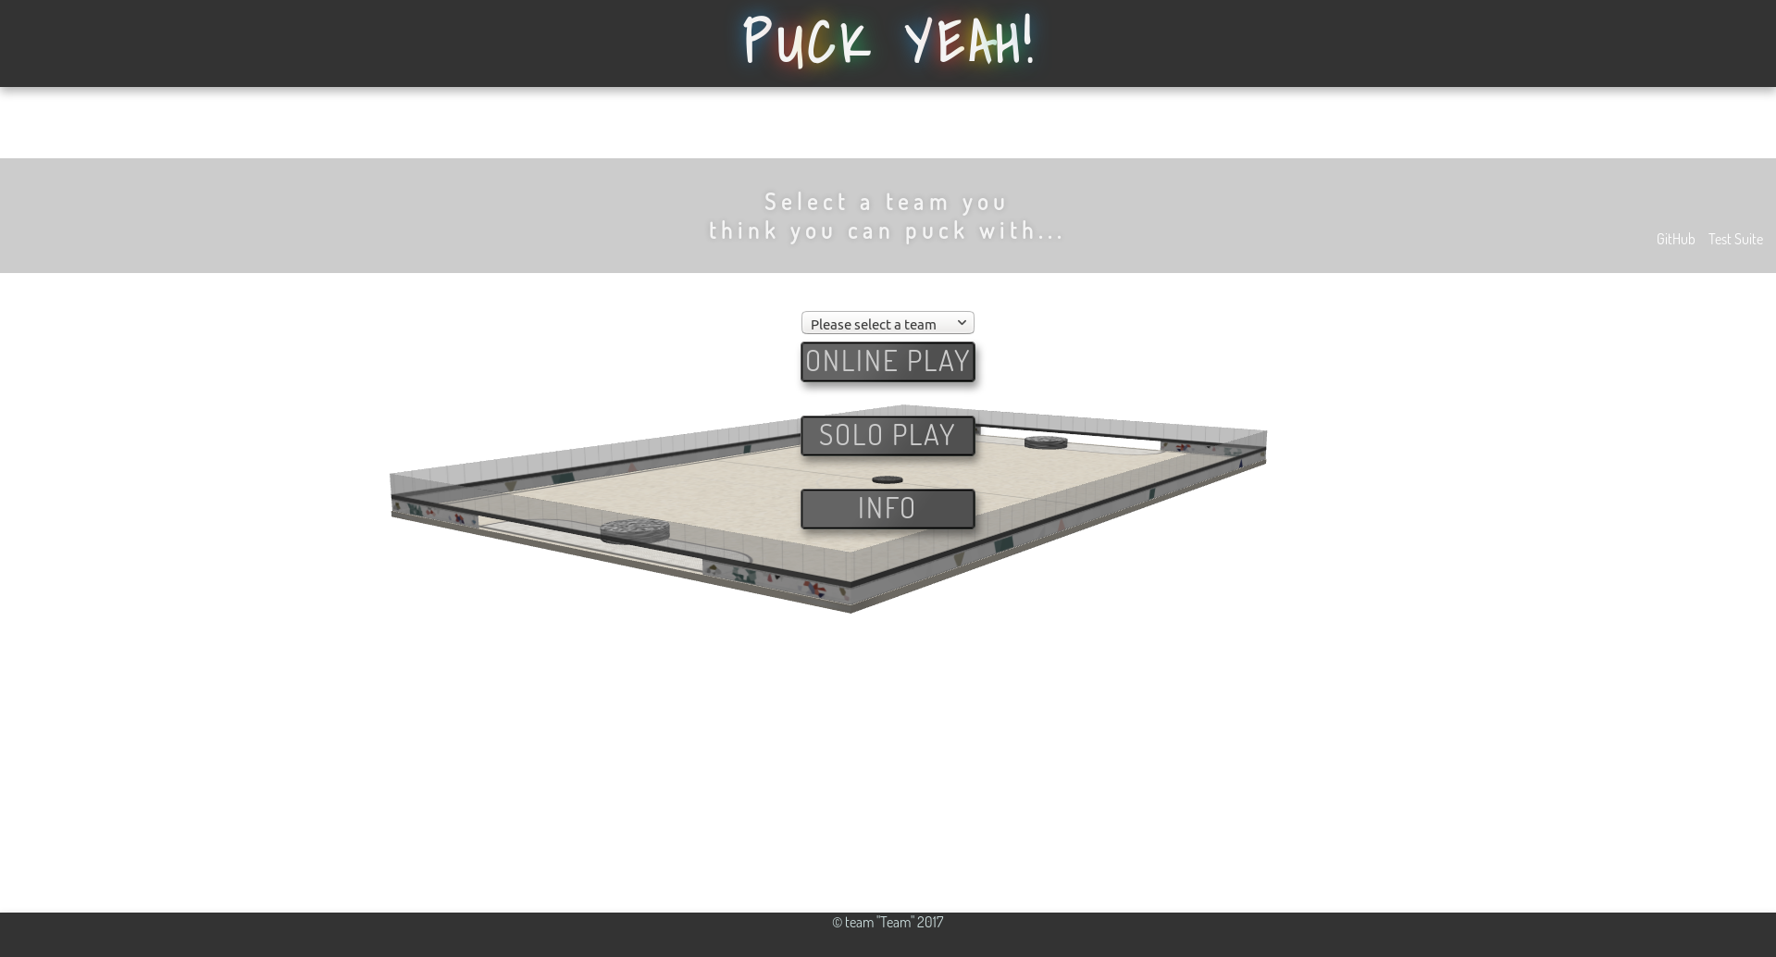

Once Puck Yeah is deployed, the maintenance is relatively simple. Essentially, maintenance would only include keeping the server and the code up and running.

As explained in the Deployment Plan, a server is required to play Puck Yeah. To maintain the game, one must maintain the server. At the most basic level, this means paying for electricity and internet.

The electricity used by the server depends on the load, or how much work the server is doing. If more people are playing Puck Yeah at the same time, then more money will be spent on electricity. Furthermore, the price of electricity depends on the location of the server.

Hypothetically, if the server always had a moderate load, it would pull around 300 W. If this server were based in Lawrence, it would cost about $0.08 per kilowatt hour. Thus, having the server on all day, every day, for a year, would cost about $200!

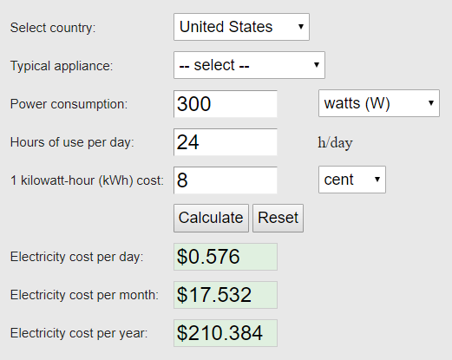

Of course, this figure is entire hypothetical and serves more as an upper bound, as the server is not expected to be under this load for extended periods of time.

Next, one must consider the internet connection required for the server. Here, the internet needed depends on several factors, including location, expected server load, price, etc. Simply to produce a figure, one can assume the server will have a moderate load at all times. To support this level of traffic, a rather fast internet speed would be preferential. As stated in the Deployment Plan, many companies provide gigabit internet packages for around $80 per month. A connection of this speed would almost guarantee a smooth experience for a player base in the thousands. Thus, for a year, one can expect to spend $960 for an internet connection.

Next, a domain is required so users can easily find Puck Yeah. As explained in the Deployment Plan, a domain can cost as little as $10 per month, depending on the name. More expensive domains do exist. For example, if somebody wanted to buy Google.com, they could. However, it would cost an astronomical amount. For Puck Yeah, a $10 per month domain should suffice.

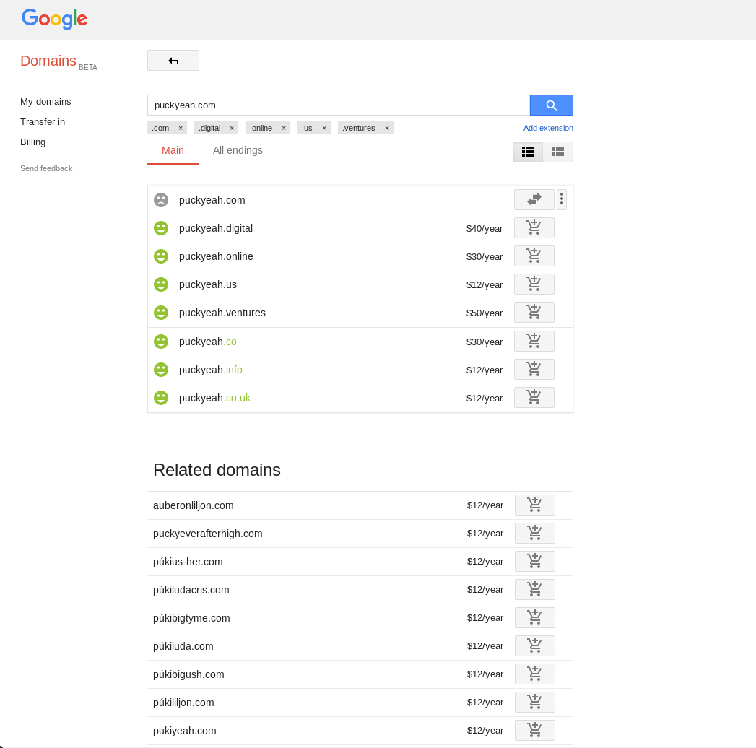

A domain would add about $120 to $144 per year to the cost of maintenance.

It is worth considering the price of replacement parts for the server. For example, the price of a hard drive dying, or the power supply failing. While these events do not happen often, the price of repairing or replacing them is not negligible. The price for repairing or replacing server hardware could be upwards of around $50 or $100 per year.

Every cost up until now has essentially dealt with the server hardware. However, the hardware is only half of Puck Yeah. The software is the aspect of Puck Yeah that users interact with directly. Because of this, it is worth maintaining the code. A game breaking bug can spell disaster for an online game like Puck Yeah. Furthermore, adding new features to the game over time could help keep players entertained, and even attract new players. Thus, hiring developers to fix bugs and produce new, interesting features is beneficial. Developers can either be payed hourly or given a salary. For a game on the scale of Puck Yeah, keeping developers on retainer, or giving them a salary, doesn’t make a lot of sense. Hiring a developer, or a small team of developers, to fix a bug whenever one is found is the most logical solution. Video game developers can be found online for about $40 per hour. Assuming they work quickly and not many bugs arise, developers may cost hundreds of dollars per year.

In conclusion, the maintenance costs for running Puck Yeah for a year would be between one and two thousand dollars. However, this is figure is for a worst-case scenario. Upon deploying Puck Yeah, people may find ways to reduce cost.

After considering the amount of money required to deploy and maintain a simple game like this, it’s not hard to see why so many websites contain advertisements.